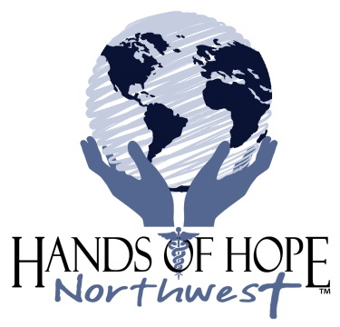

**Hands of Hope Northwest**

**Application for the Liz Murtland**

**$500 World Impact Scholarship**

**Name:**

**Address:**

**Phone number:**

**E mail address:**

**Name of Parents/Guardian**

**Church Affiliation**

**Comment briefly on the following:**

1. **Describe your involvement with Hands of Hope Northwest in the past 12 months. How much time have you spent at Hands of Hope?**
2. **Identify your career goals.**
3. **Identify the college you plan/are attending, your major in college and the reason you selected the major.**
4. **Furnish your present cumulative grant point average.**
5. **Provide evidence of your involvement in the community in efforts to benefit the marginalized population.**
6. **Describe your leadership in your church, school and community.**
7. **Prepare an essay of not more than 500 words explaining the connection between community health and evangelism.**

**Submit the following with the application:**

* **Copy of most recent transcript**
* **Evidence of acceptance/enrollment in college**
* **Letter of reference from your pastor/Sunday School teacher/or youth group leader**
* **Letter of reference from current/recent teacher/professor**

**In applying for the scholarship you will agree to:**

* **an interview by the Applicant Review Committee**
* **publicity regarding your award**

**Completed application must be submitted via email by March 31 . Please call the office at 208-461-1473 for the email address.**

**On subject line indicate “HOH Scholarship Application”**

**__________________________ ______________**

**Signature Date**